Voice DevOps

Objective = Only build those applications which can earn money right from Build# 1

https://ifttt.com/
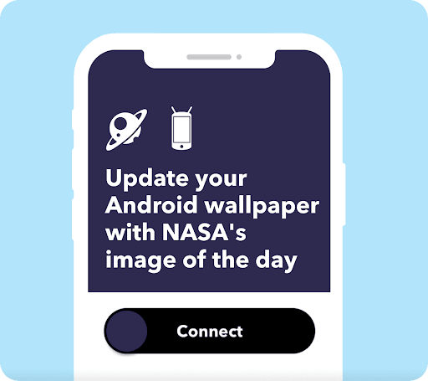
IFTTT
ifttt.com

Ruhan Asghar

reinforced learning
scrappy beautifulsoup4

google voice to text engine

python

Intial Design Date 31-august-2022

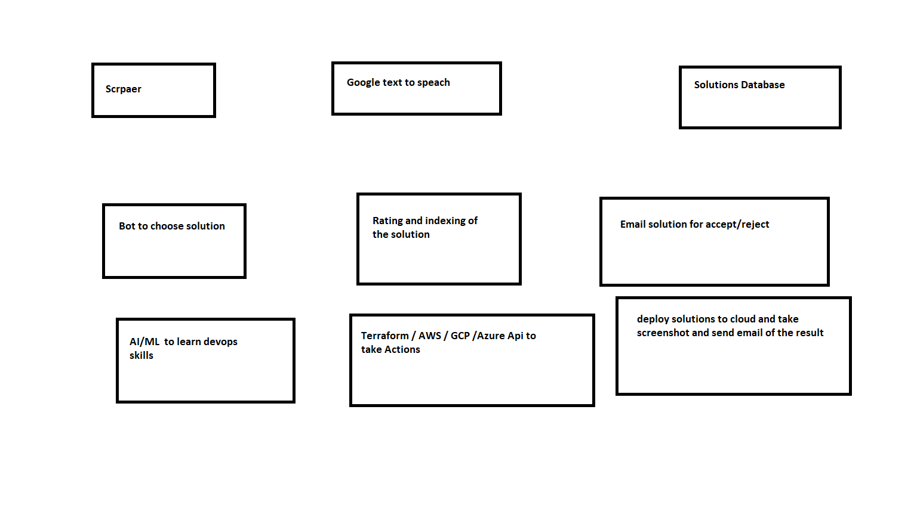
desgin

1. Scrapper must learn from google = text and from YouTube = voice and video

2. Scrapper also save pictures related to the topics

3. and also can create videos realted to topics and publish it on youtube

4. create software / service house that is only built on AI and Bot based

DevOps, .net Programmer, Tester, Database administrator etc.

